**Chapter 1**

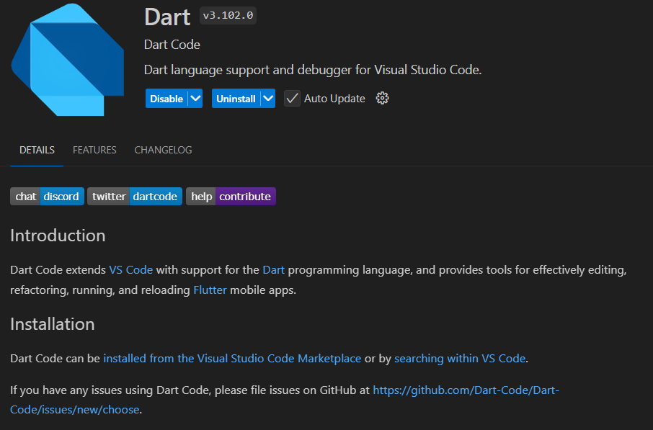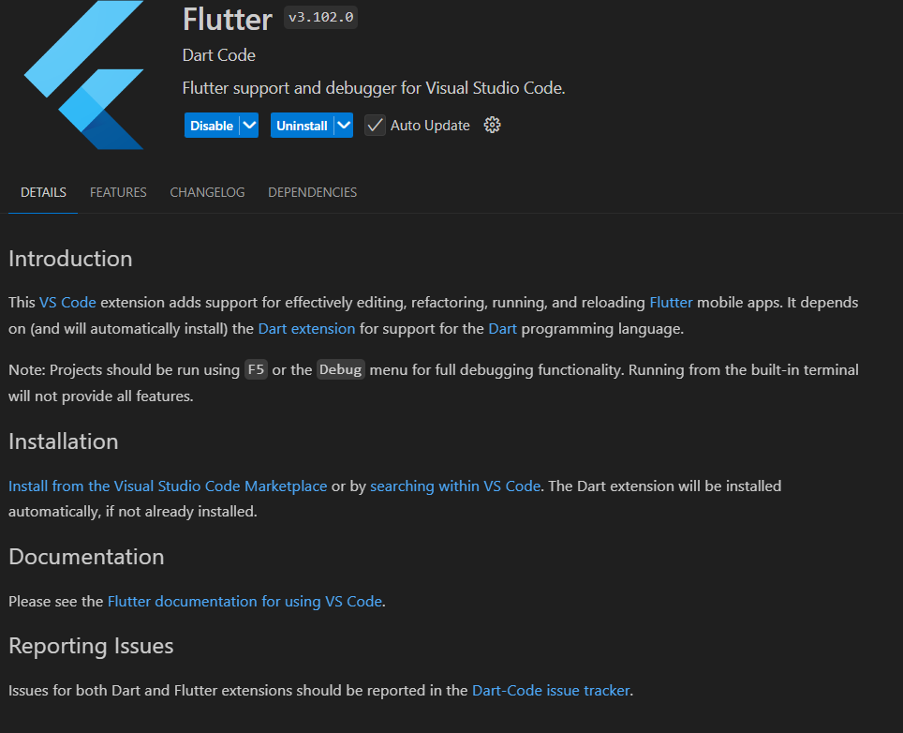Learning Flutter and Dart is an exciting journey, especially for building cross-platform apps efficiently. Dart, the programming language used in Flutter, is the starting point. It’s essential to grasp its syntax, including variables, functions, classes, and asynchronous programming with async and await. Flutter, on the other hand, is a UI toolkit where everything is a widget. Understanding the widget tree, along with stateless and stateful widgets, is fundamental. Setting up the development environment and starting with simple projects like a to-do list or a counter app helps solidify the basics. As you progress, diving into more advanced topics such as state management, networking with APIs, and local data storage is crucial. Integrating plugins, experimenting with Firebase, and focusing on responsive design add more depth to your skills. Regular practice, referring to official documentation, and engaging with the developer community ensure continuous growth. Learning Flutter and Dart becomes highly rewarding when combined with consistent effort and hands-on experience.